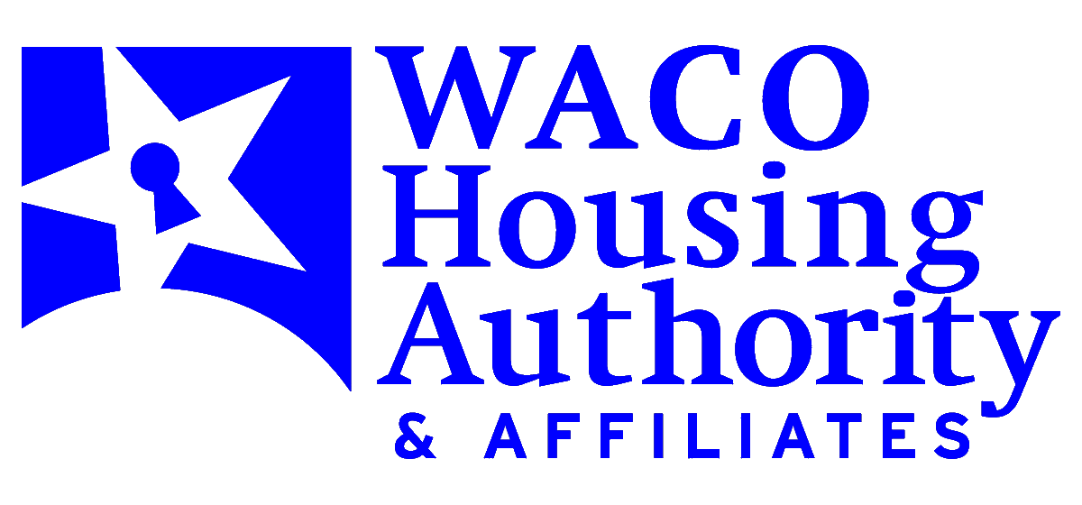

July 1, 2024

**New Changes – Housing Opportunities through Modernization Act – HOTMA**

**Implementation of Sections 102 & 104**

Housing & Urban Development (HUD) has implemented new guidelines under the Housing Opportunities through Modernization Act (HOTMA). Some of the following changes are effective at your annual re-certification beginning October 1, 2024, other implementations are applicable

upon further guidance from Housing & Urban Development:

Household Income – changed exclusion of income for Independent Contractor, Day Laborer, Seasonal Worker, all household income is included (24 CFR 5.609(b)(24) and 5.603(b).

Unless specifically excluded (24 CFR 5.100) (24 CFR 5.609(b)24(i) – (b)(24)(vii).

Earned Income Disallowance – No longer applicable. Removed as of January 1, 2024.

Elderly Deduction – changed from $400 to $525 for an elderly/disable household (24 CFR 5.611(a)(2).

New Higher Threshold for Deducting Health and Medical Care Expensed and Unreimbursed Reasonable Attendant Care and Auxiliary Apparatus Expenses- changed from 3% to 10%. Medical expenses must exceed 10% of annual income (24 CFR §5.611(a)(3)(i)-(ii). This change will be phased in over 2 years (5% in year 1, 7.5% in year 2; 10% after 24 months, unless family qualifies for a new exemption).

Employment verifications cannot be more than 120 days of receipt. A statement dated within the appropriate benefit year for fixed income sources i.e. Social Security Income, Pension.

Self-Certification for Assets – If net family assets are $50.000.00 or less. Imputed return on assets over $50,000.00 based on passbook savings rate as determined by Housing & Urban Development (24 CFR 5.609(a)(2) and (b)(1).

Change in rent – If income decreases, there will not be an interim change, unless the reduction

of income results in tenant portion of rent decreasing by more than 10%. There will not be an interim change, unless the increase in tenant portion of rent increases by more than 10%.

The Higher Educating Act requires that all assistance under Title IV of the HEA and Bureau of Indian Affairs student financial assistance is excluded.

**Income determination is being made using pre-Housing Opportunities through Modernization Act (HOTMA) regulations.**